<!DOCTYPE html>
<html>
<head>
<title>RegEx Validation</title>

<style>
body {
font-family: Arial, sans-serif;
background: #f4f6f8;
display: flex;
justify-content: center;
align-items: center;
height: 100vh;
}

form {
background: white;
padding: 25px;
width: 300px;
border-radius: 8px;
}

h2 {
text-align: center;
margin-bottom: 20px;
}

input {
width: 100%;
padding: 8px;
margin-top: 5px;
border: 1px solid #ccc;
border-radius: 4px;
}

.error {
color: red;
font-size: 12px;
margin-bottom: 10px;
display: block;
}

button {
width: 100%;
padding: 10px;
background: #2563eb;
color: white;
border: none;
border-radius: 4px;
cursor: pointer;
}
</style>
</head>

<body>

<form onsubmit="return validate()">
<h2>Form Validation</h2>

Name
<input type="text" id="name">
<span class="error" id="nameError"></span>

Phone
<input type="text" id="phone">
<span class="error" id="phoneError"></span>

Email
<input type="text" id="email">
<span class="error" id="emailError"></span>

Password
<input type="password" id="password">
<span class="error" id="passwordError"></span>

Date (DD-MM-YYYY)
<input type="text" id="date">
<span class="error" id="dateError"></span>

<button type="submit">Submit</button>
<p id="success" style="color:green; text-align:center;"></p>

</form>

<script>
function validate() {

// clear old errors
document.querySelectorAll(".error").forEach(e => e.innerHTML = "");
document.getElementById("success").innerHTML = "";

let name = document.getElementById("name").value;
let phone = document.getElementById("phone").value;
let email = document.getElementById("email").value;
let password = document.getElementById("password").value;
let date = document.getElementById("date").value;

let valid = true;

if (!/^[A-Za-z ]{3,}$/.test(name)) {
document.getElementById("nameError").innerHTML =
"Name must have at least 3 characters";
valid = false;
}

if (!/^[0-9]{10}$/.test(phone)) {
document.getElementById("phoneError").innerHTML =
"Phone number must be exactly 10 digits";
valid = false;
}

if (!/^[a-z0-9]+@[a-z]+\.[a-z]{2,}$/.test(email)) {
document.getElementById("emailError").innerHTML =
"Enter valid email";
valid = false;
}

if (!/^[A-Za-z0-9@#]{6,}$/.test(password)) {
document.getElementById("passwordError").innerHTML =
"Minimum 6 characters";
valid = false;
}

if (!/^\d{2}-\d{2}-\d{4}$/.test(date)) {
document.getElementById("dateError").innerHTML =
"Use DD-MM-YYYY";
valid = false;
}

// SUCCESS
if (valid) {
document.getElementById("success").innerHTML =
"Submitted successfully ✅";

// clear form
document.querySelector("form").reset();

// hide success message after 3 seconds
setTimeout(() => {
document.getElementById("success").innerHTML = "";
}, 3000);
}

return false; // prevent page reload
}
</script>

</body>
</html>

Output

Here Are The Outputs of regEx Codes which will validate the texts which are taken input from the user
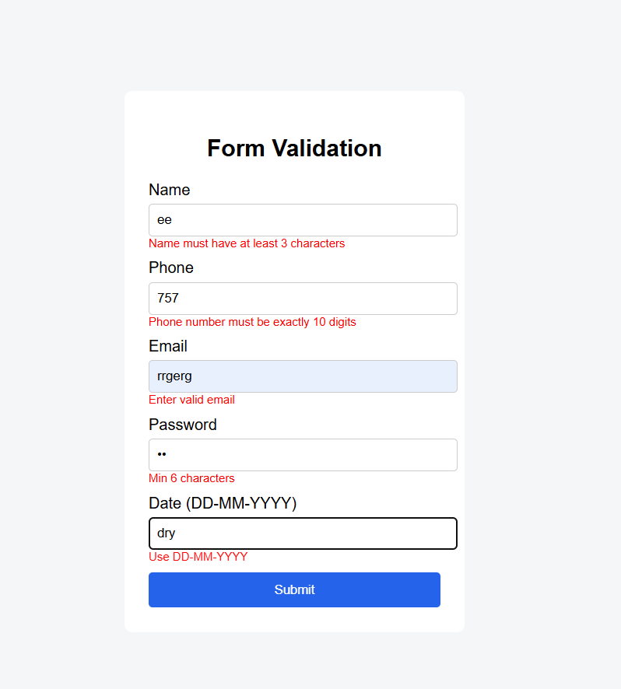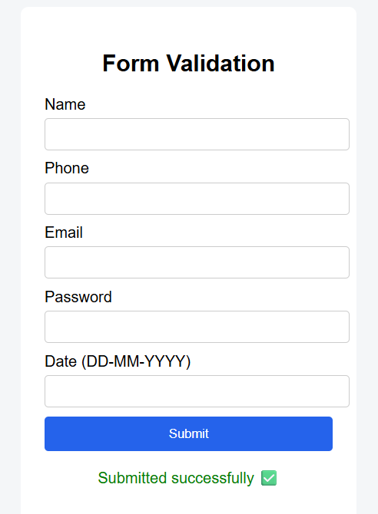

MouseEvents:
<!DOCTYPE html>
<html>
<head>
<title>All Mouse Events</title>

<style>
body {
font-family: Arial;
background: #f4f4f4;
text-align: center;
padding-top: 40px;
}

#box {
width: 250px;
height: 250px;
background: #64748b;
color: white;
margin: auto;
line-height: 250px;
font-size: 18px;
cursor: pointer;
border-radius: 10px;
}

#msg {
margin-top: 20px;
font-size: 16px;
color: #1e293b;
}
</style>
</head>

<body>

<h2>Mouse Events Mini Project</h2>

<div id="box"
onclick="clickEvent()"
ondblclick="dblClickEvent()"
onmouseover="mouseOverEvent()"
onmouseout="mouseOutEvent()"
onmousedown="mouseDownEvent()"
onmouseup="mouseUpEvent()"
onmousemove="mouseMoveEvent()">
Mouse Box
</div>

<p id="msg">Perform mouse actions on the box</p>

<script>
function clickEvent() {
document.getElementById("msg").innerHTML = "Mouse Clicked";
}

function dblClickEvent() {
document.getElementById("msg").innerHTML = "Mouse Double Clicked";
}

function mouseOverEvent() {
document.getElementById("box").style.background = "#2563eb";
document.getElementById("msg").innerHTML = "Mouse Over";
}

function mouseOutEvent() {
document.getElementById("box").style.background = "#64748b";
document.getElementById("msg").innerHTML = "Mouse Out";
}

function mouseDownEvent() {
document.getElementById("msg").innerHTML = "Mouse Button Pressed";
}

function mouseUpEvent() {
document.getElementById("msg").innerHTML = "Mouse Button Released";
}

function mouseMoveEvent() {
document.getElementById("msg").innerHTML = "Mouse Moving...";
}
</script>

</body>
</html>

OutPuts:
Here Are the outpus of MouseEvents ,which include onMouseOver,out,in ,hover like all
